1. Creating and Renaming Files/Directories

Create a directory named test_dir using mkdir.

Inside test_dir, create an empty file called example.txt.

Rename example.txt to renamed_example.txt using mv

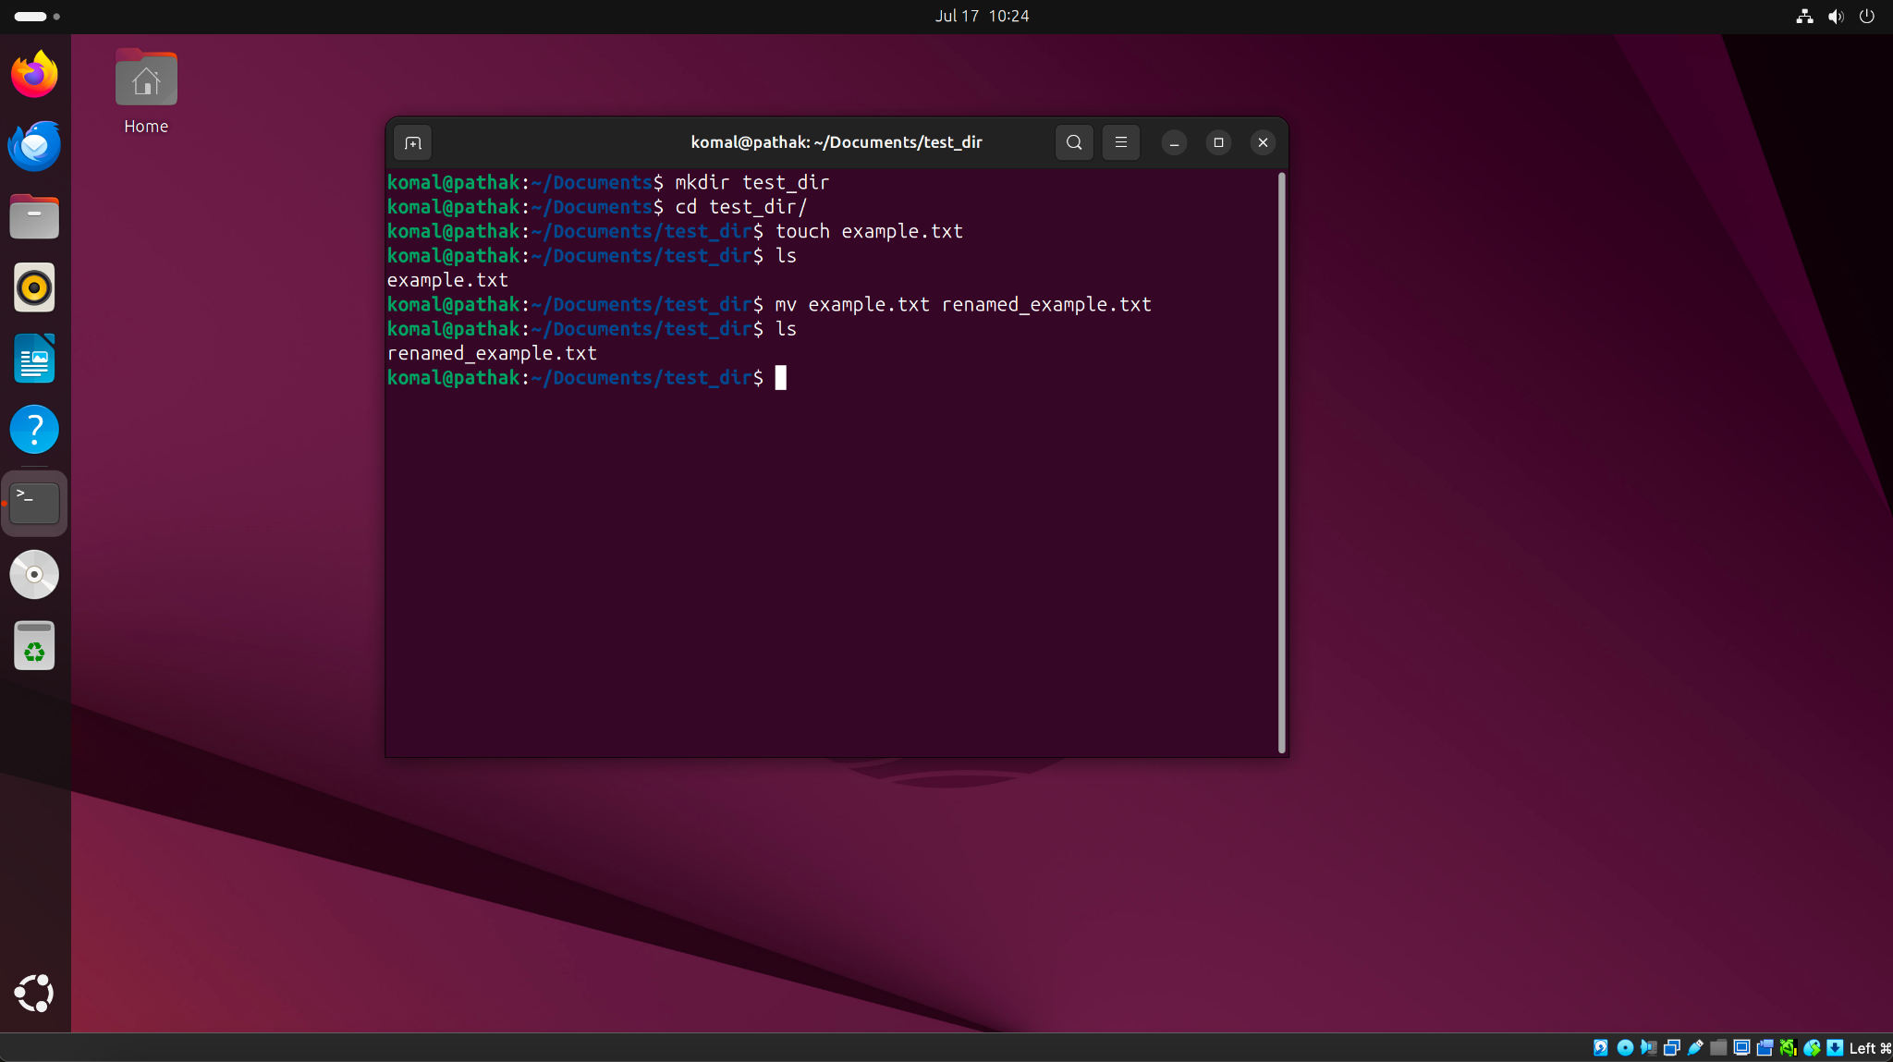  
mkdir test_dir - to create a new directory named test_dir.  
cd test_dir - to navigate/ change directory from documents to test_dir.  
touch example.txt - to create a new file.  
ls - to list the content of the directory.  
mv example.txt remanded_example.txt - to rename the file.

2. Viewing File Contents

Use cat to display the contents of /etc/passwd.  
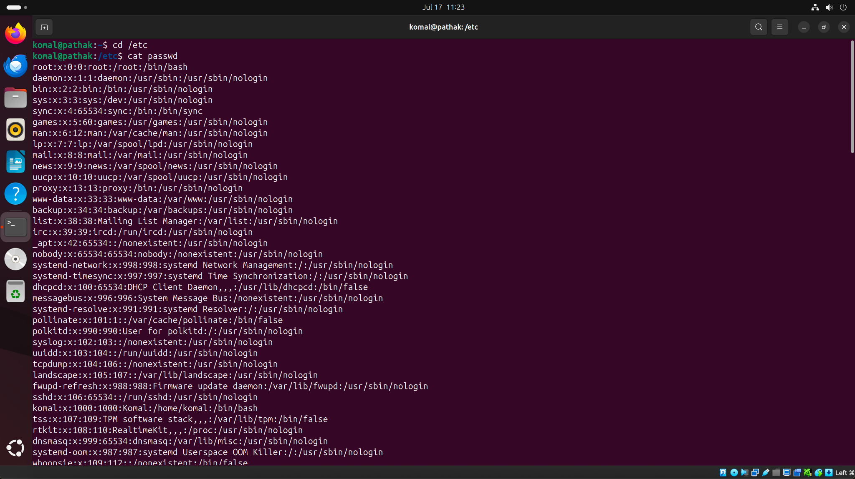

Display only the first 5 lines of /etc/passwd using head.  
Display only the last 5 lines of /etc/passwd using tail.

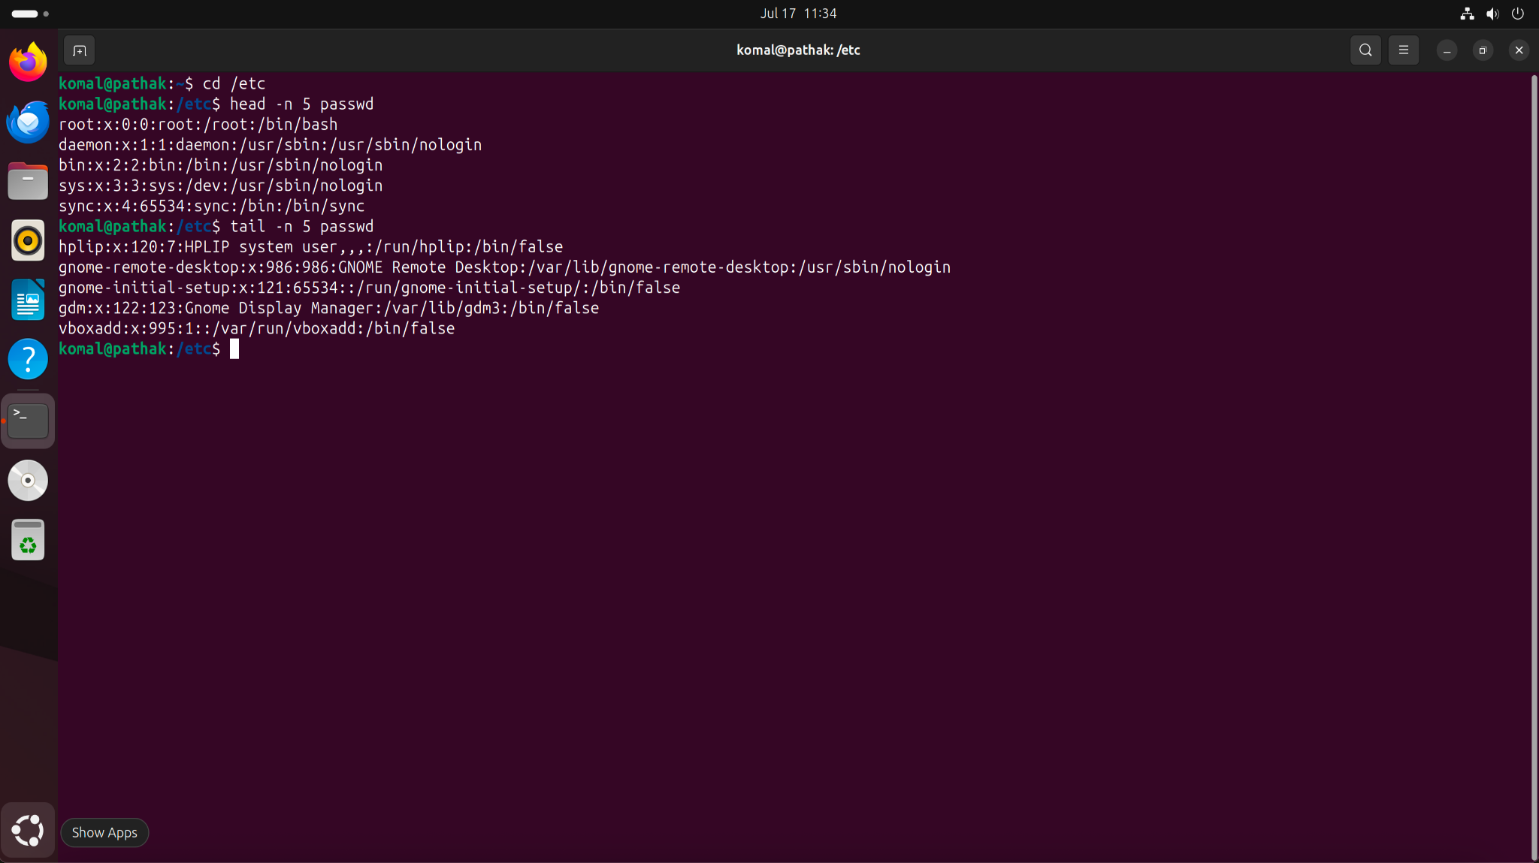

3.Searching for Patterns

Use grep to find all lines containing the word "root" in /etc/passwd.

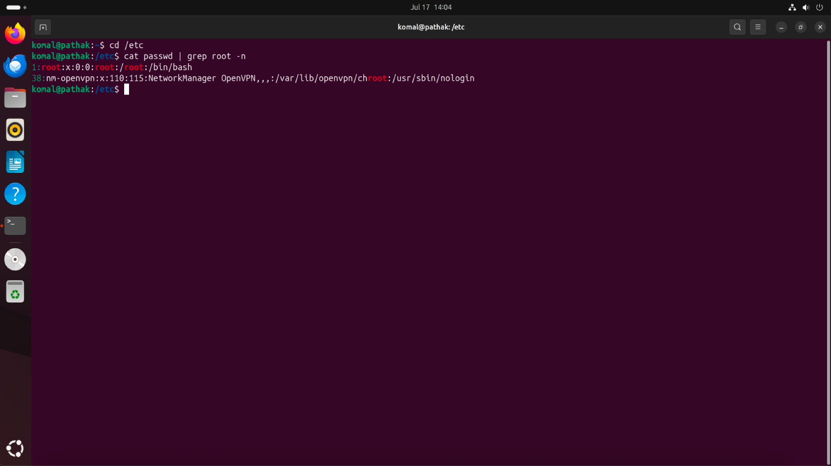

Cat - to display the content.  
grep - to search word “root” in the passwd file.  
-n - to display the number of the line.

4. Zipping and Unzipping

Compress the test_dir directory into a file named test_dir.zip using zip.

Unzip test_dir.zip into a new directory named unzipped_dir.

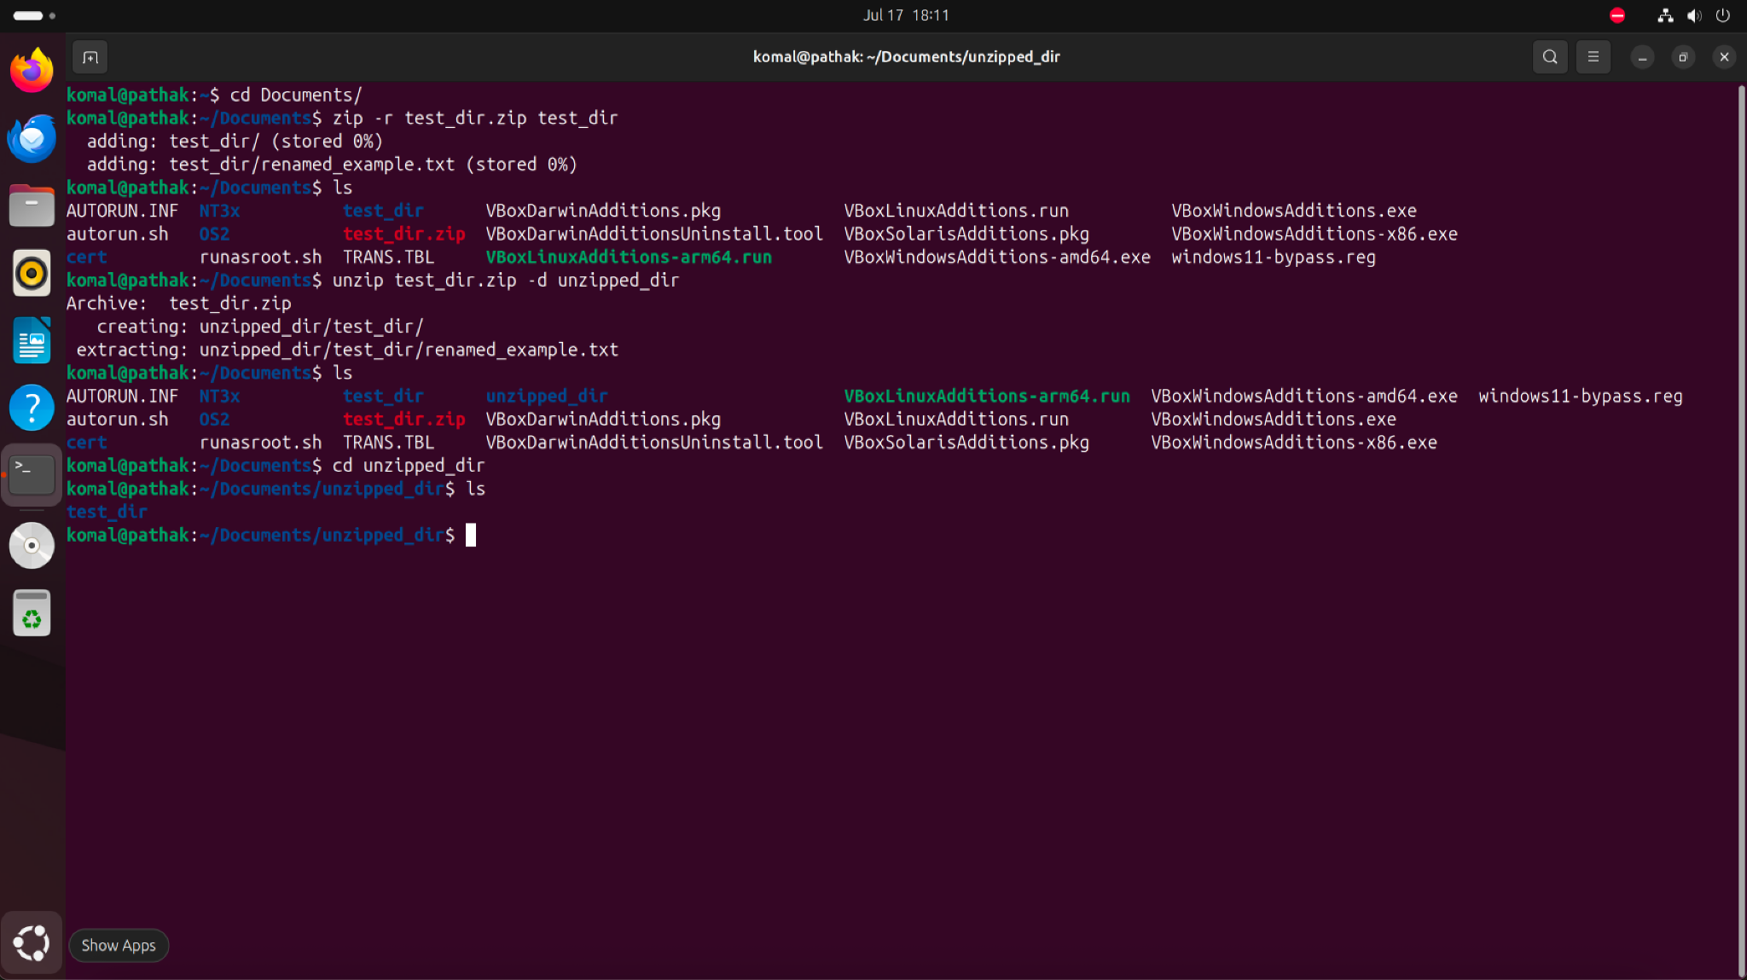

5. Downloading Files

Use wget to download a file from a URL (e.g., <https://example.com/sample.txt>).

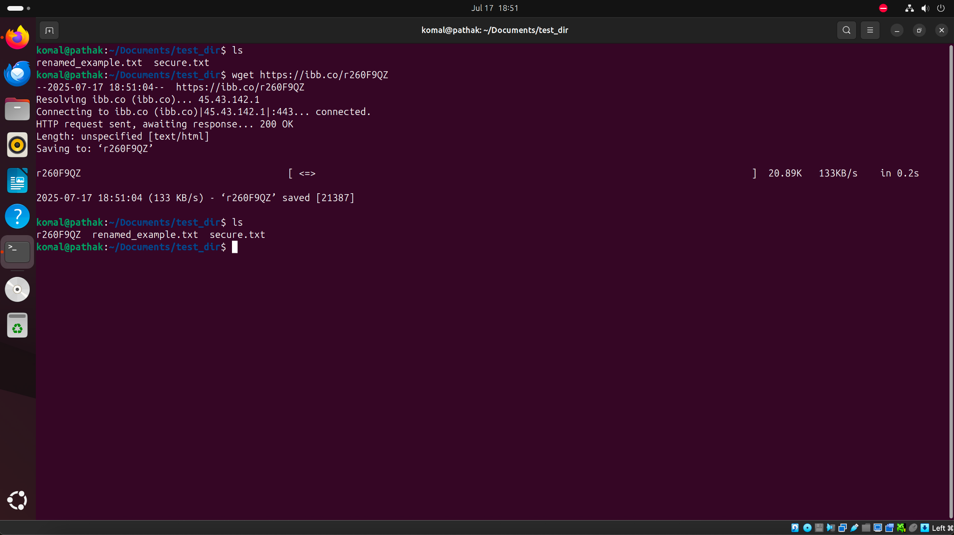

6. Changing Permissions

Create a file named secure.txt and change its permissions to read-only for everyone using chmod.  
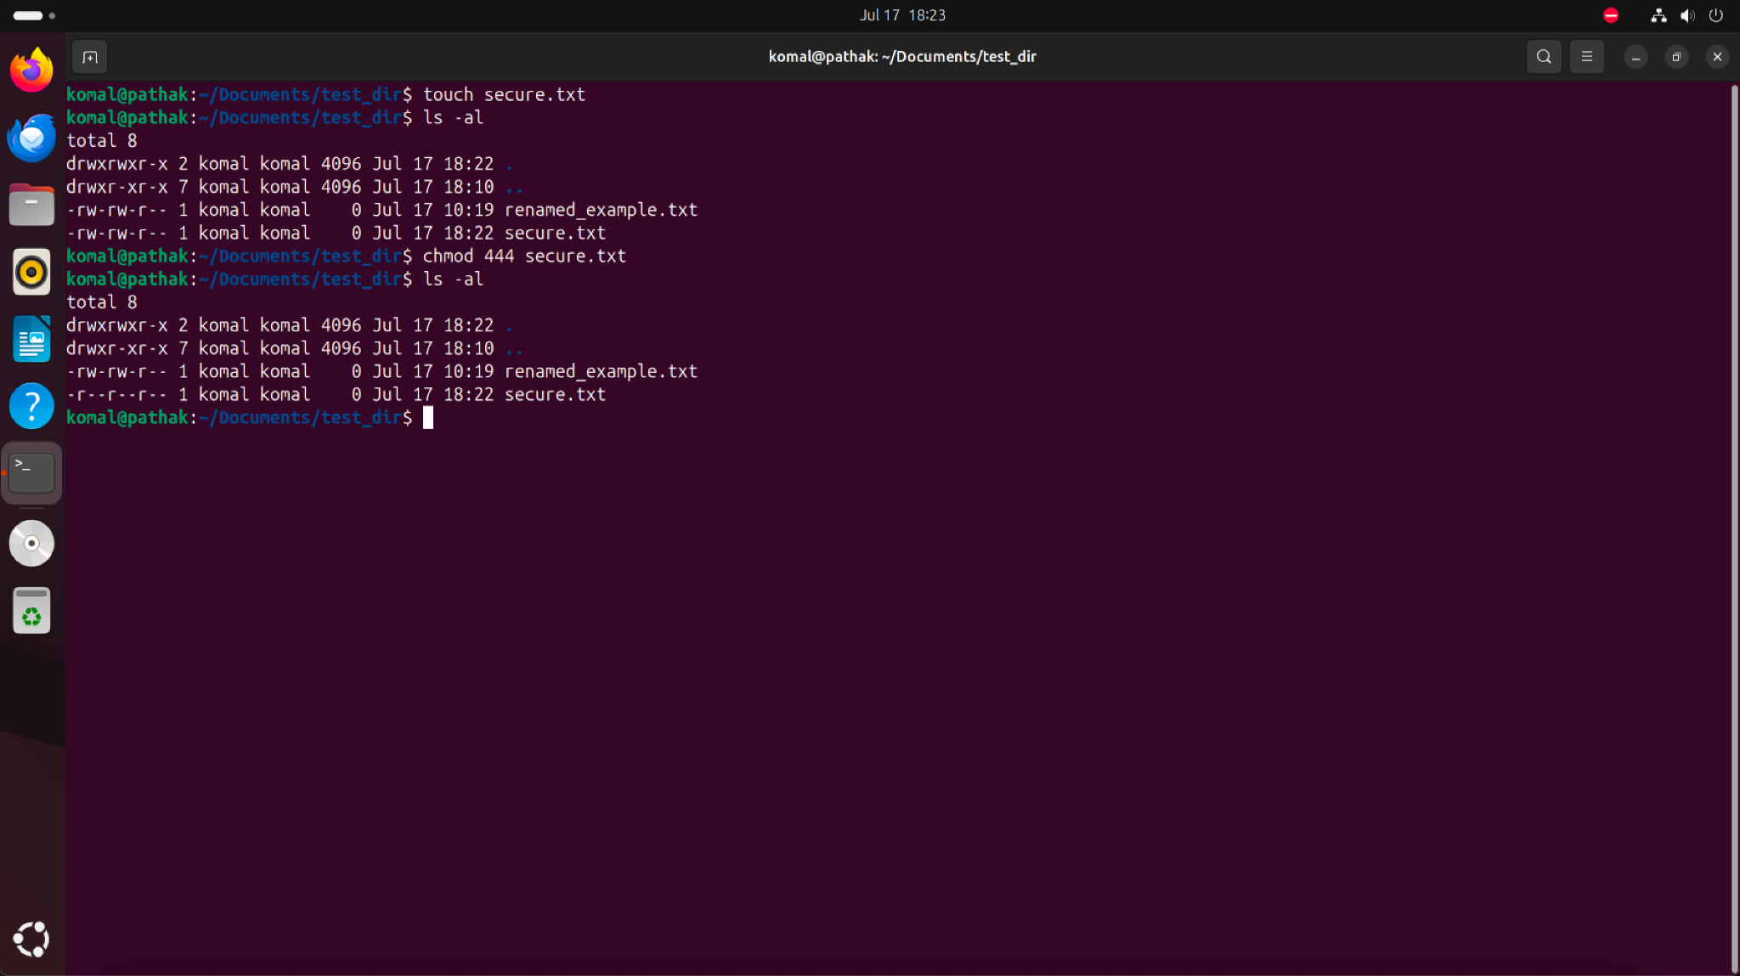

7. Working with Environment Variables

Use export to set a new environment variable called MY_VAR with the value "Hello, Linux!".

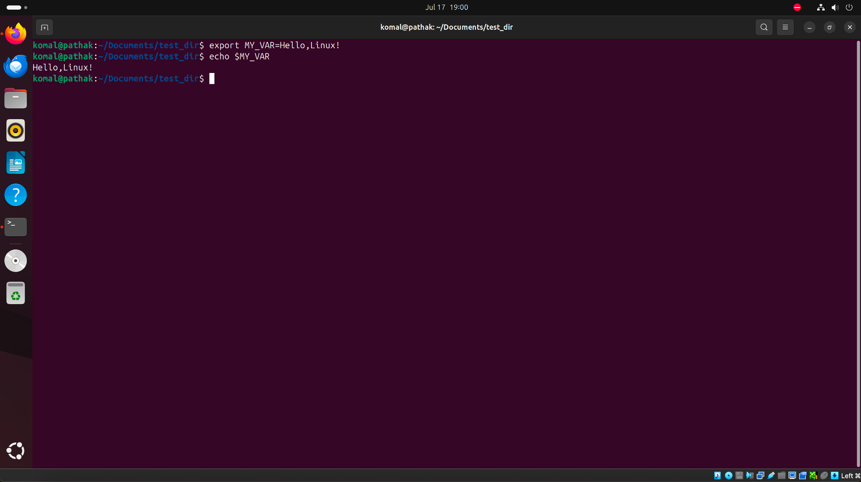

Github repo link: https://github.com/Pathakkomal11/DevOps